Snowball Project with Reinforcement Learning

Project Report

LU GUANNAN

20446054  
Big Data Technology  
 HKUST

@connect.ust.hk

DANILL

20460529  
Big Data Technology  
 HKUST

@connect.ust.hk

HUANG YILUN

20458655  
Big Data Technology  
 HKUST

@connect.ust.hk

SUN CHENXI

20450976  
Big Data Technology  
 HKUST

csunae@connect.ust.hk

context

1. INTRODUCTION 3

1.1 Background 3

1.2 Concept of project and data 3

2. DESIGN REQUIREMENT 4

3. DESIGN IMPLEMENTATION 4

4. EVALUATION AND CONCLUSION 7

4.1 Project result 7

4.2 Result analysis 7

4.3 Challenge of experiment 7

4.4 Further improvement 8

# INTRODUCTION

## Background

Sometimes, it is common that the significance of selecting and entering a major that associated with students interests is overstated. This is not reasonable for the reason that it cannot be sure that the major they interested in is the major fit them. ACT has conducted some research and has shown that students tend to keep the same or similar majors in their first year of college as their indicated planned major over time. And by research ACT has data of them about the fit level of their indicated major and best-fit major index, which is quite helpful for students to know about themselves and can predict the prospect according to the fit level about their interested and indicated major.

The majors students interested in cannot be necessary the major actually fit them. The ACT does the research and has data regarding students’ measured—rather than self-reported—interests and has developed a “fit index” that can help accurately predict success based on their fit with selected or intended majors. But from the data, it is not clear about the useful features and patterns about the attributes, and the original data cannot present the correlation with them. VPG’s contest challenge is to develop a visual representation of Interest Perceived vs. Actual data that helps to relate the complexities of how students’ measured interests match with their indicated plans, declared majors, or their persistence into their sophomore year.

So, appropriate data processing and design visualization is significant, which can help viewers to have a intuitive and clear sight of the data.

## Concept of project and data

The ACT (originally an abbreviation of American College Testing) is a [standardized](https://en.wikipedia.org/wiki/Standardized_test) [test](https://en.wikipedia.org/wiki/Test_(student_assessment)) used for [college admissions](https://en.wikipedia.org/wiki/University_and_college_admissions) in the [United States](https://en.wikipedia.org/wiki/Education_in_the_United_States). It was first introduced in November 1959 by [University of Iowa](https://en.wikipedia.org/wiki/University_of_Iowa) professor [Everett Franklin Lindquist](https://en.wikipedia.org/wiki/Everett_Franklin_Lindquist) as a competitor to the [Scholastic Aptitude Test (SAT)](https://en.wikipedia.org/wiki/SAT). It is now administered by [ACT](https://en.wikipedia.org/wiki/ACT_(nonprofit_organization)), a nonprofit organization of the same name.

An brief introduction of all the attributes of data is as follows：

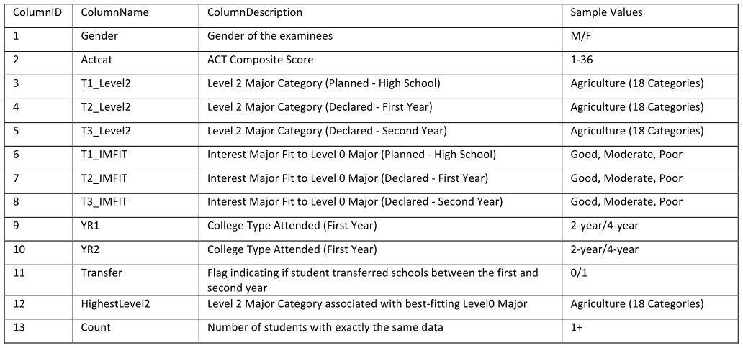

Table 1: *the basic information of all attributes*

There are thirteen attributes in this research which present the information about the gender, the ACT scores, the major from these 18 majors students planned and declared in three years, the fit levels of their majors in these years, the college types and whether or not did they transform major and last but not least their best-fitting major.

# DESIGN REQUIREMENT

The main line of the visualization design is to study the case of majors mobility in three years. Major mobility can be learned from which professions more favored by students over time, from the dynamic visualization design, we can clearly see the flow of each major. At the same time, students' majors, ACT scores, and fitness levels need to be explored to see which majors have higher levels of fitness and better ACT scores.  
It is worthy of exploding the relationship between gender and ACT scores and fit levels, and we can see whether boys or girls overall achieve higher ACT scores or better major fit level. Whether there is a correlation between ACT scores and major fitness, we need to know through the visualization research. In addition, the mobility of time is a very important feature, and we can see if there is a change in students' interest in various majors over time.

The information we want to cover in our visualization is the influx and outflow between 18 majors at 2 time stamps and distribution of majors and students’ information within each major

The problem we what to solve is as follows:

What majors have the largest influx/outflux of students?

Which majors have had an increase or decrease in measured interest over time?

Which majors are most affected by the influx/outflux of students?

# DESIGN IMPLEMENTATION

## Basic visualization

In the beginning, we try to implement some basic visualization on Tableau to take a glance at the data. We draw some pie charts and histograms (Figure. 1) to figure out the distribution of important features.

Insight 1.1 Female takes nearly 60% of students.

Insight 1.2 Male students have better performance on ACT test.

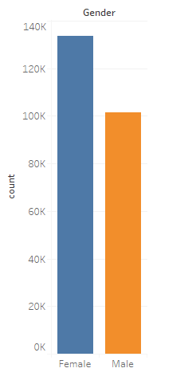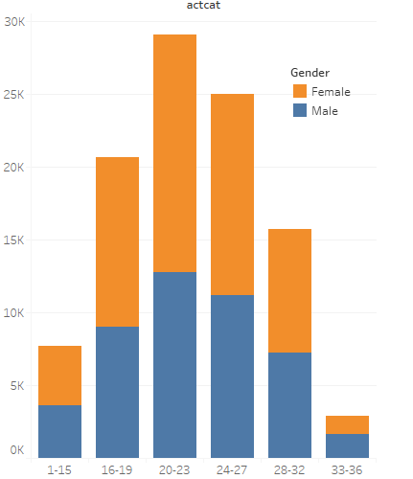

Figure 1: *The distribution of gender and ACT score*

Then, we draw a horizontal histogram of T1_Level2 (major a student want to take before ACT test) (Figure 2.). We can also dig out some insights:

Insight 1.3 Some popular majors come into our eye. Top 5 majors are Health Sci. & Techno., Social Sciences & Law, Sciences: Biological & Physics, Engineering, Business.

Insight 1.4 Boys and girls tend to like different majors. For example, girls tend to like Arts, Health Sci. & Techno. while boys tend to like Engineering

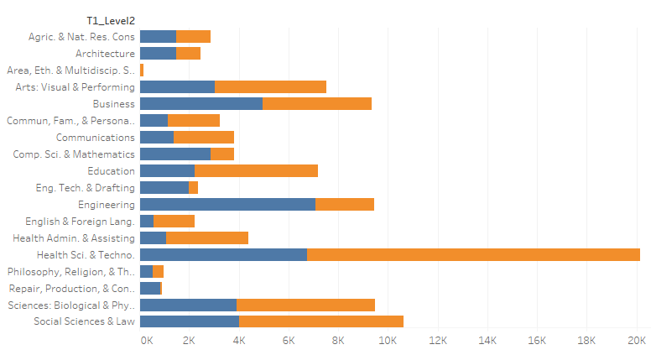

Figure 2: *the indicated major distribution in high school between male and female students*

What’s more, we have drawn some similar graphs for the second year and the third year. There is no evident change from Figure 2.

Then, we try to figure out the fitness index (T1_IMFIT) in each major (Figure 3).

Insight 1.5 The distribution of fitness index of each major is similar. However, Good fitness usually is difficult but in the popular majors listed above, the proportion of Good fitness is significantly higher, which shows that in popular majors, students is more suitable for their majors.

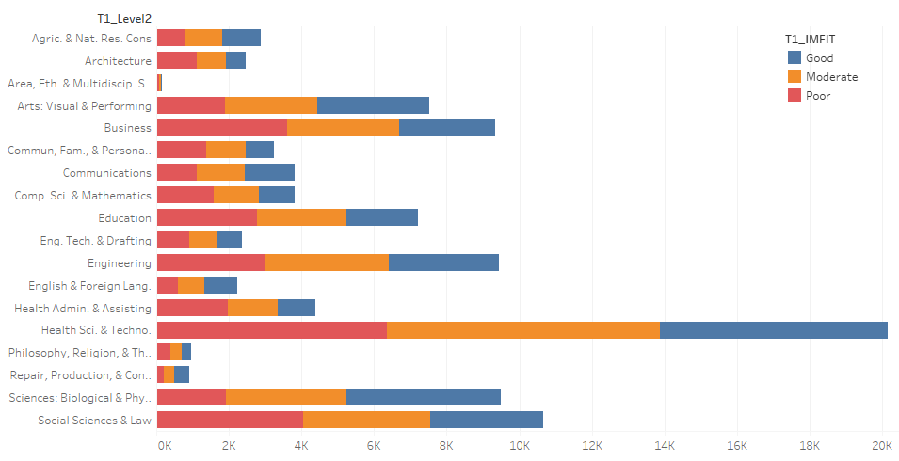

Figure 3

## Chord diagram

After getting high-level knowledge of our case from some basic visualization, we try to implement advanced technology to visualize it.

We try to draw a chord diagram by D3.js.

This chord diagram can show the flow of majors between three years, which means T1_Level2 to T2_Level2 to T3_Level2

## 3.3 Parallel coordinates

Besides the chord diagram, we also try to visualize the relationship between features we have. We draw a parallel coordinates graph by Baidu Echarts (Figure 4).

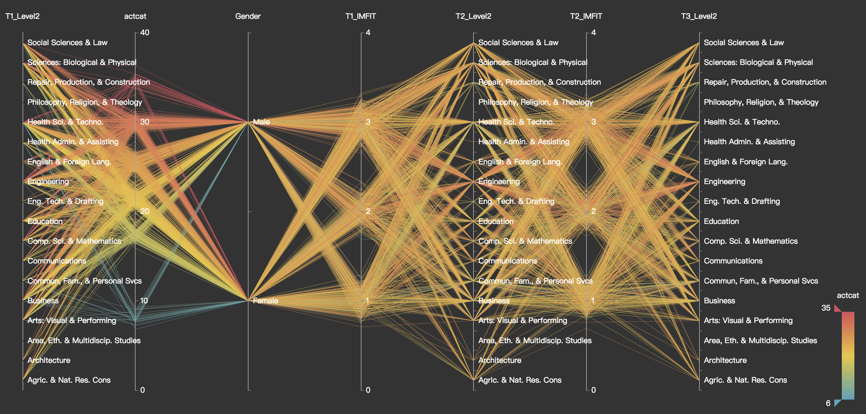

Figure 4

This is a dynamic diagram. In every coordinate, we can drag a sliding block to filter the data. After filtering, we can get more insights from the graph.

In Figure 5, we filter on ACT score (actcat). We can easily get some inshghts:

Insight 3.1. Students with good score (around 30) tend to choose popular majors we find out in Insight 1.3.

Insight 3.2. There are more male than female among students with good score (around 30). However, among students with moderate score (around 20), females more than males.

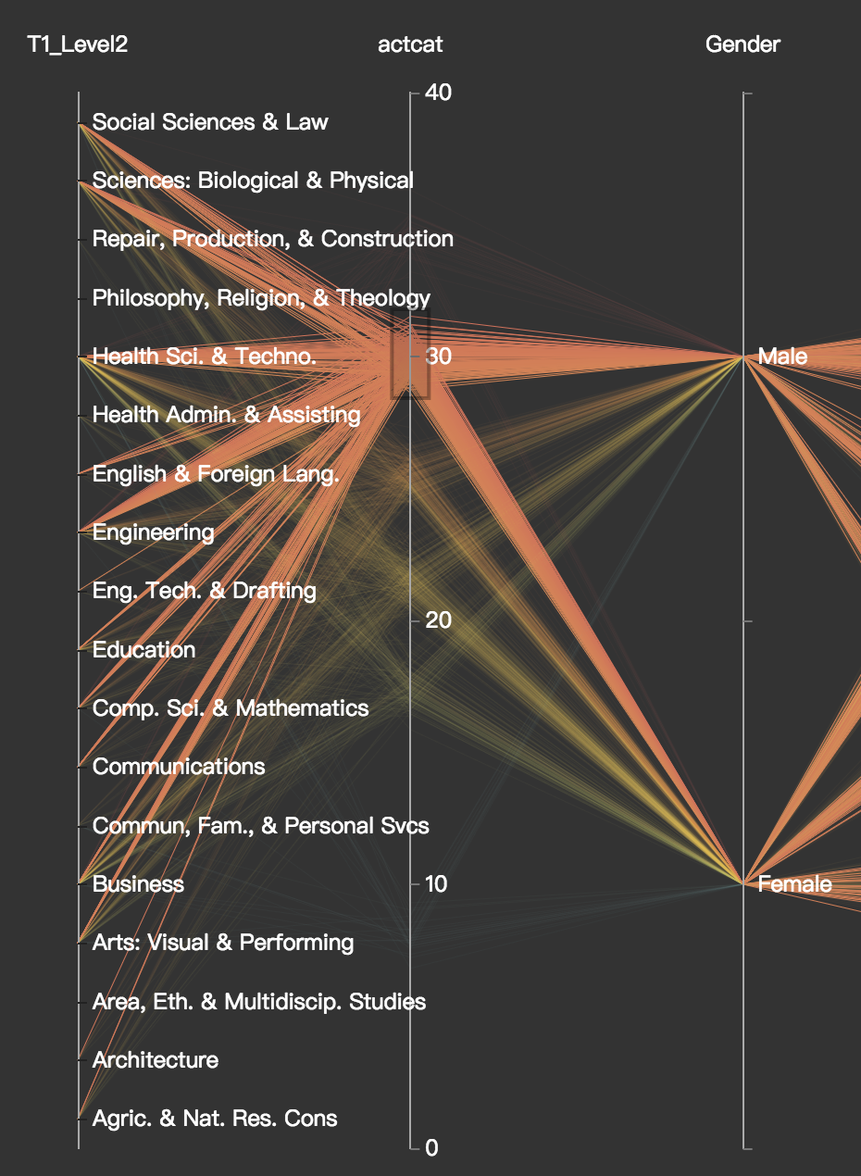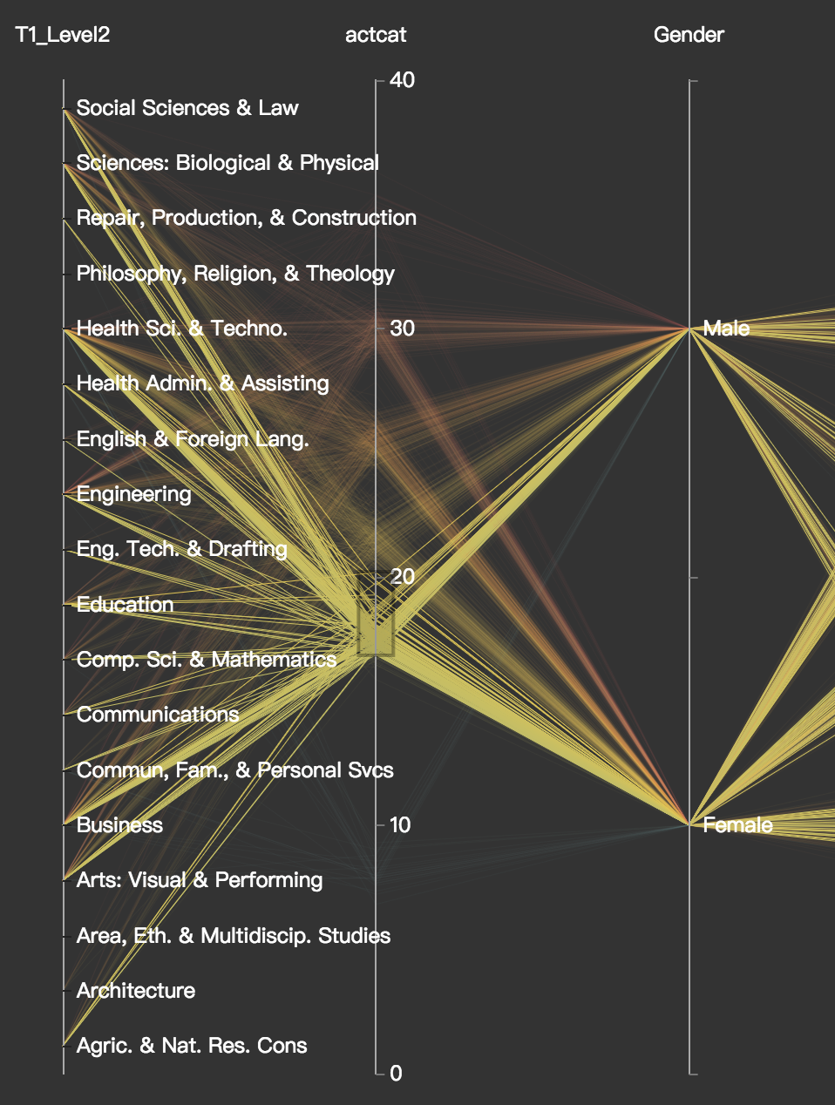

Figure 5

Then, we focus on the relationship between ACT score and fitness index (T1_IMFIT) (Figure 6).

Insight 3.3. Students with higher ACT scores tend to choose a major that fits him.

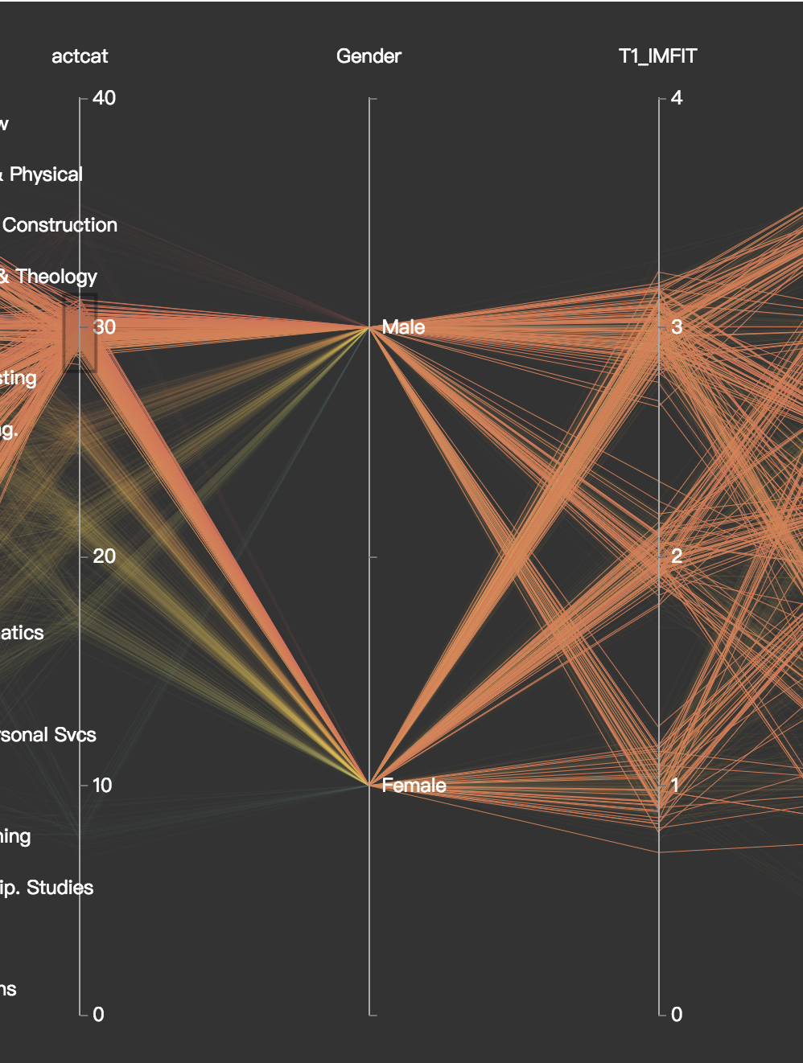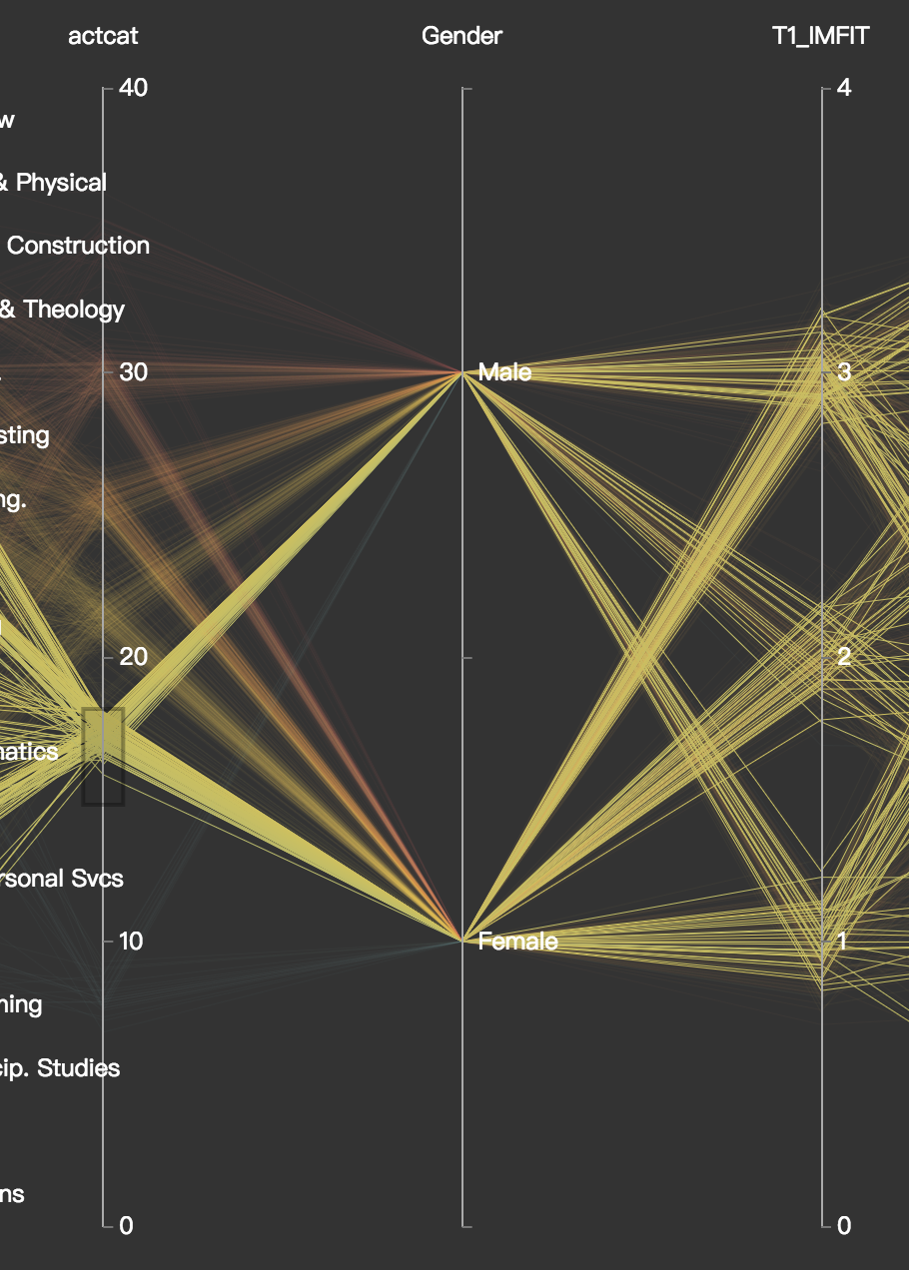

Figure 6

After that, we choose one major - Engineering as a specific example to dig out some insights inside it.

From overview (Figure 7), we can see the feature distribution of students whose interest is Engineering.

Insight 3.4. Students who are interested in Engineering mainly has a good ACT score (upon 20).

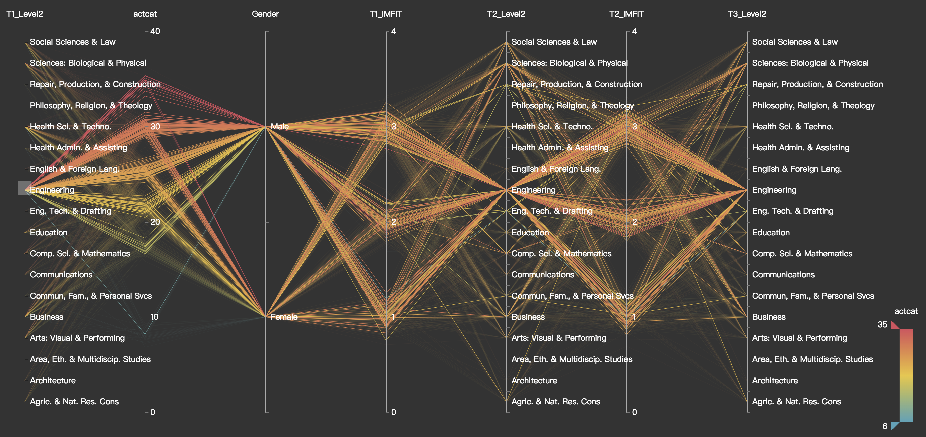

Figure 7

Then, we filter on fitness index. And find out:

Insight 3.5. From Figure 8, we find that students with lower fitness index (around 1, which means poor) has larger probability of choosing different major when entering university (T1_Level2 not equal to T2_Level2). However, from Figure 9, students with higher fitness index don’t tend to change their majors, staying in Engineering.

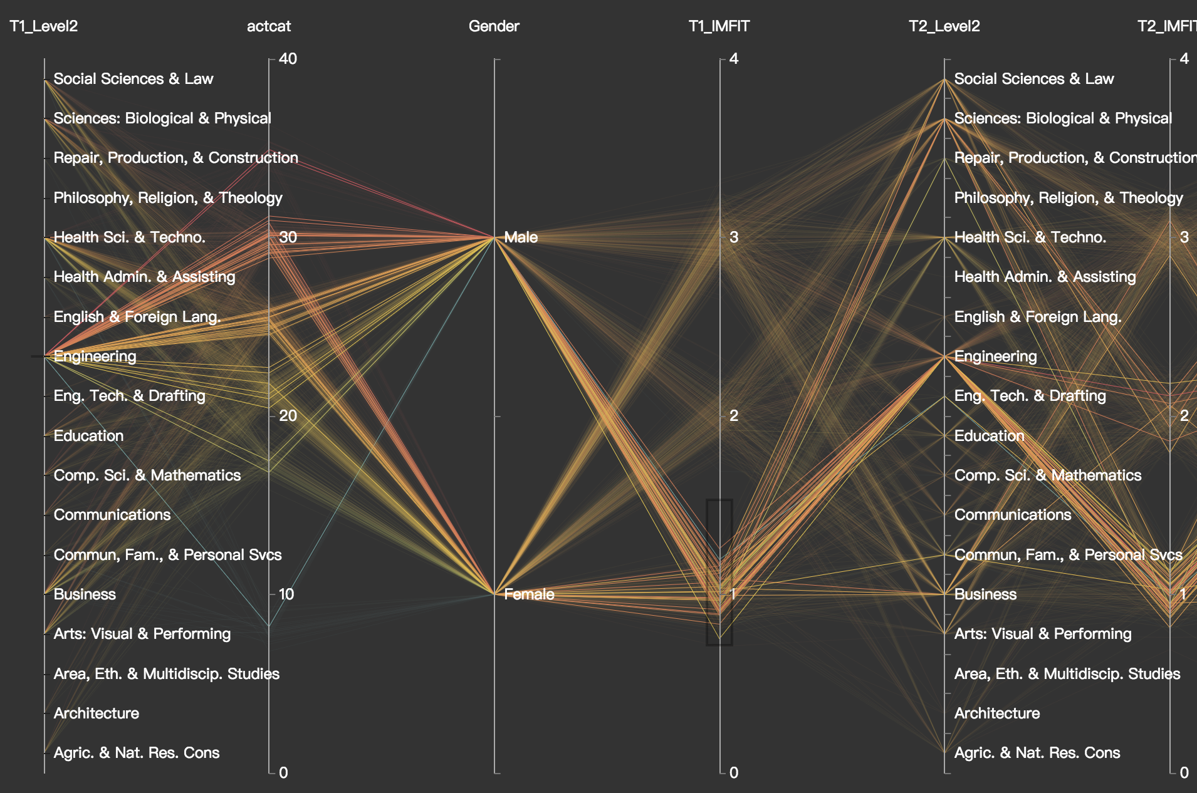

Figure 8

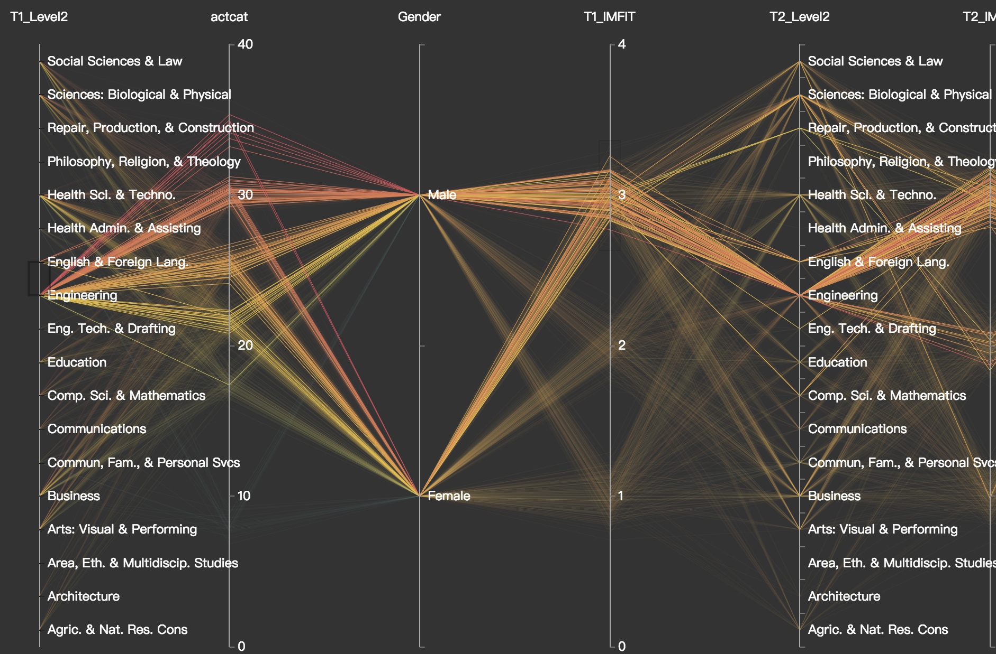

Figure 9

Fixed T2_Level2, which means the students’ major in the first year, we find:

Insight 3.6 Different majors have different composition, including Dreamed major sources, ACT score and genders. From Figure10, we can see the students of Engineering comes from many different major sources with high ACT score. There are also more lines come from Male point than Female point, which means male students are the majority. However, as for Health Science & Technology, most students continue to study this major which is their original dreaming major , though their ACT score may be lower than Engineer students’ average scores. And there are more female students than male studens.

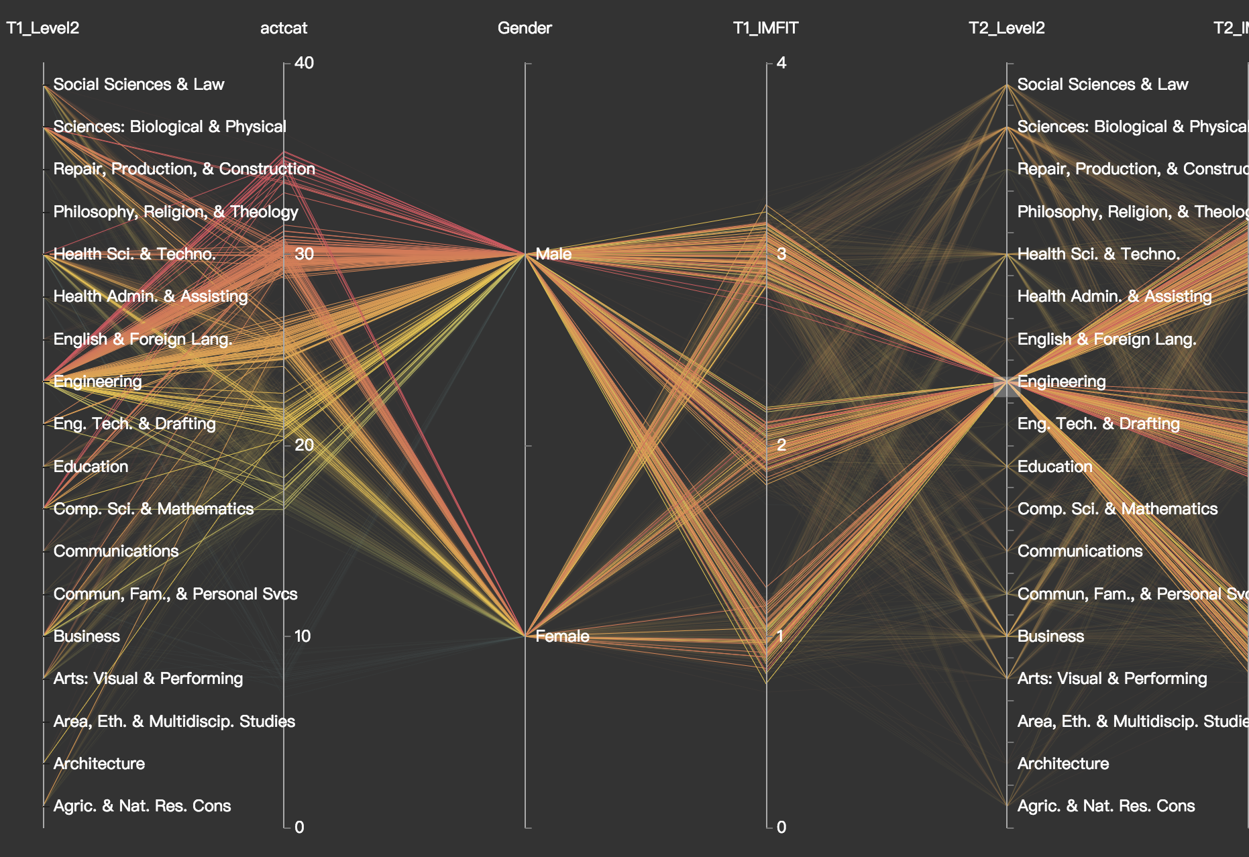

Figure 10

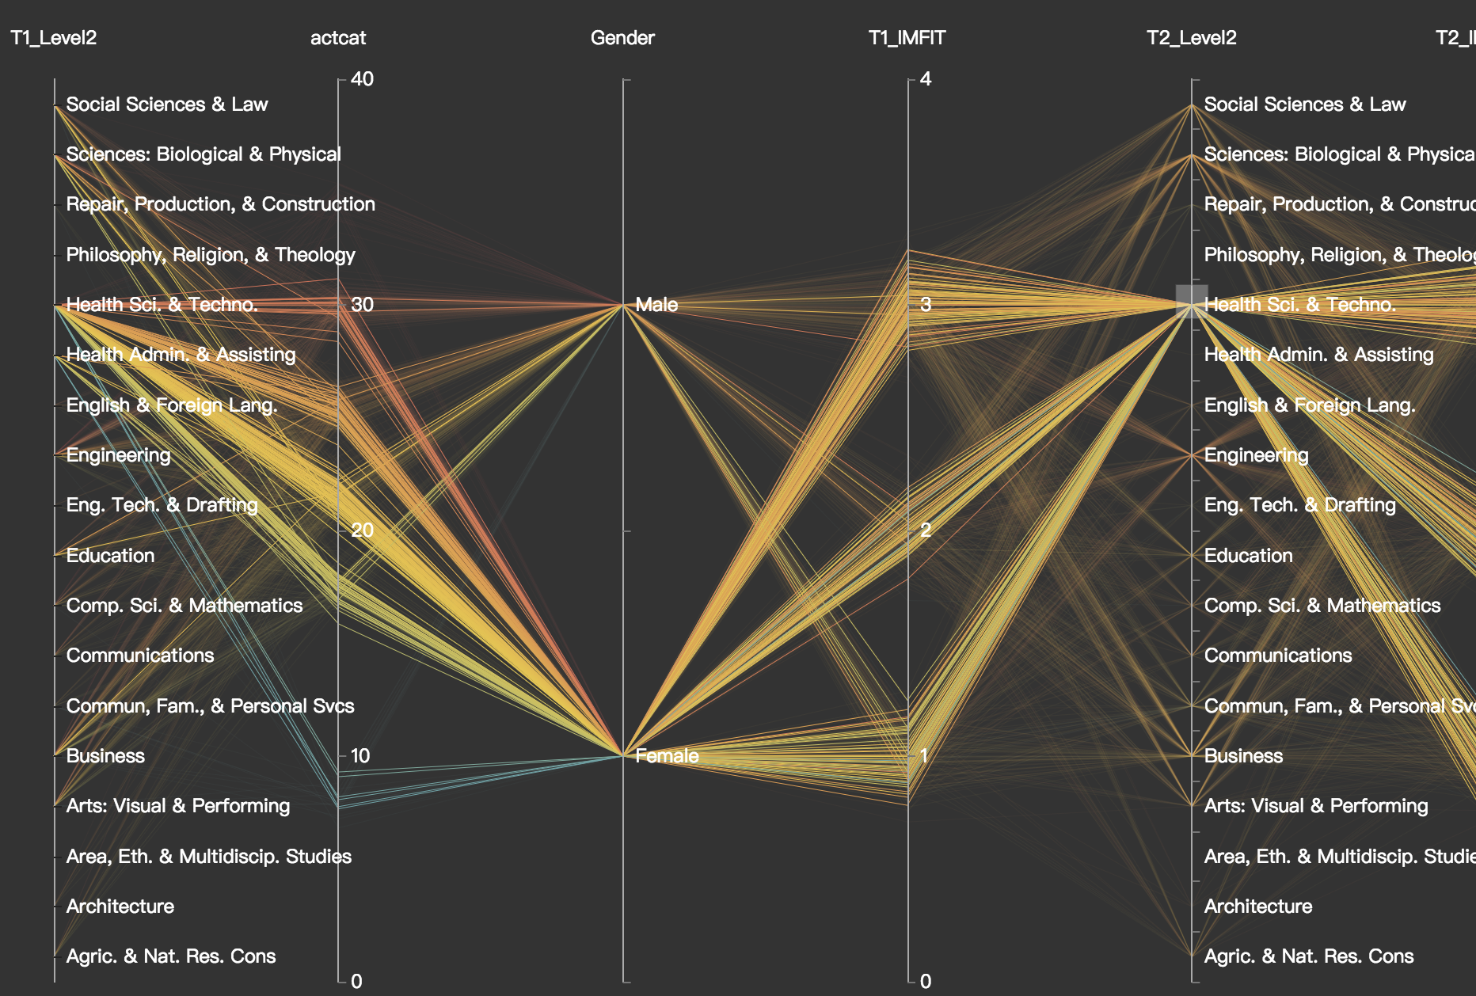

Figure 11

# EVALUATION AND CONCLUSION

## Project result

From this visualization project, we have a deep research about the data of about the students’ self-interested major and the measured fit major. From the major students transformed in these three years, we can have a conclusion that the high-level ACT-score students mainly choose the majors of engineering, science, biology, physical, health science and business. From the high school year to the first year, most students who have relatively low fit level tend to transform their majors.

For the correlation between ACT score and the major, we can know about that for the major of engineering, most of the students are in relatively high score interval, and the proportion of male is larger. About the ACT-score and gender, it is clear that as the score increasing, the proportion of high ACT-score in male students is also increasing.

## Result analysis

## Challenge of experiment

In the progress of visualization, we meet several challenges. For example, the vast data makes the visualization effect have a serious overlapping problem, it is a question to think about and make a reasonable distribution of attributes which can present a clear view of the data.

Moreover, it is a challenge to sort out ideas about such many attributes and construct useful correlations among them. Determining the directions of research has to cost much time and a pivotal step. And two times major transformation is the main line of the visualization, we try to combine these two changes and flows in one visualization view but continuously change our plan because merge three distributions in one figure make it much crowded and cannot present better effect as parts.

## Further improvement

To further optimize visualization design, it is worth thinking about how to improve the comprehensiveness of the visualization. It is quite important to combine more attributes in visualization, which can present more correlation in each attributes.